DFO-LEP Acoustic Target Data Issues (1977-2007).pdf

Read_Me
This section is reproduced as a separate pdf on the Government of Canada Open Data site.

READ_ME
Project Name: DFO-LEP Acoustic Target Data (1977-2007)
Authors of cleaned dataset: Yuliya Shtymburska, Howard Stiff, Athena Ogden, Sandra Emry
Agency Supervisors: Howard Stiff (Howard.Stiff@dfo-mpo.gc.ca), Athena Ogden (athena.ogden@dfo-mpo.gc.ca), Patrick Thompson* (Patrick.Thompson@dfo-mpo.gc.ca), principal dataset contact
Intern: Yuliya Shtymburska (ysf307@uregina.ca)
Date file was created: June 10, 2025
Date file was finalized: January, 2026

The Datasets
These acoustic target data were collected as part of DFO’s Lake Enrichment Program (LEP). See Hyatt et al. (2000), Hyatt et al. (1984) and Gjernes et al. (1986) for background details on acoustic limnetic fish census methods employed to obtain fish counts for the LEP. Ideally, the acoustic target data should be considered together with the trawl biosampling data. See references section.

Data Collection
Data were collected in freshwater lakes located in British Columbia, Canada, from 1977 until 2007 (and a few surveys in early 2008 that were part of the cohort that was sampled in 2007). Data were collected using hydro-acoustic counts from echo-sounders of “fish-like targets” (FLT). The echosounder data were originally processed by lab technicians using proprietary software associated with the echosounders, and saved into annual datafiles titled TARGETyy.DAT, where yy indicates a two-digit value representing sampling years from 1977 to 2007, and refers to the Sockeye juvenile salmon cohort year. The cohort year spans an April – March timeframe, from 01-Apr-yy to 31-Mar-yy+1, and is also referred to as the acoustic-trawl-survey year, or “ATS year” (details below; see section
Target_CHK_exact_duplicate_records – list of records removed due to duplication of data across all fields or columns
- Target_CHK_keyfield_duplicate_surveys – list of surveys duplicated on key fields (lake, survey_date, survey_type, sounder_type)
- Target_CHK_sequential_surveys – list of surveys that occur within one day of each other for the same lake, representing possible replicate surveys (change in field survey method (e.g., sounder type), or lab analysis method (e.g., software used, technician performed).
- Target_CHK_targets_issues – list of remaining records (if any) with anomalous data issues
- Target_CHK_RAW_vs_CLEAN_surveys – inventory of records organized by whether they exist only in TARGETyy.DAT files (i.e., omitted from cleaned dataset), only in cleaned data (programmatic additions or key-field revisions), or in both.
The contents of these files are further described in “DFO-LEP Acoustic Target Data Issues (1977-2007).pdf”.
Note that the ACOUSTIC TARGET DATA CLEANUP LOG.txt file shown above contains the RStudio console output of a successful run of the R program (not automatically saved to the \output folder).

Output Data Review
While the CSV files can each be opened in MS-Excel or read into R for review and further analysis, a quick look at the R program’s output files can be obtained with the included Excel workbook: “Target_OUTPUT_CHK_data_PIVOT.xlsx”. This workbook contains multiple worksheets, each automatically linked to a corresponding CSV file for ease of data display, filtering, and pivot summary.
Once initial setup is performed (see details in section “To Use the Target Output Checking Data Workbook” in “DFO-LEP Acoustic Target Data Issues (1977-2007).pdf”), the data in “Target_OUTPUT_CHK_data_PIVOT.xlsx” worksheets are automatically updated with the contents of the CSVs upon opening the workbook or refreshing the data.

Additional Metadata Included as a ZIP File
The zip file, DFO-LEP Acoustic Target Data (1977-2007).zip, contains the following folders, following the subdirectory structure of the RStudio project employed to run the Acoustic Target Data Cleanup.R program:
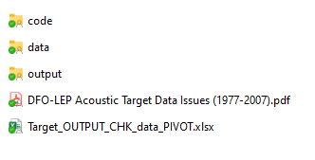
Descriptions of Variables). The TARGETyy.DAT files are essentially text files and are readable by a text editor such as Notepad.

Data Cleaning
The TARGETyy.DAT files are imported into data-cleaning software developed by a team comprising Yuliya Shtymburska (Canadian Institute of Ecology and Evolution), Howard Stiff (DFO), Athena Ogden (DFO), and Sandra Emry (Canadian Institute of Ecology and Evolution). The R program (R Core Team 2023) Acoustic Target Data Cleanup.R was used to compile and clean the import data, which were unchanged by the process. R version 4.3.1 was used, and RStudio 2024.09.1 Build, 394.
Note that the DFO staff who assisted with the data extraction and cleaning (i.e., Howard Stiff and Athena Ogden) were not part of DFO’s Acoustic and Trawl Survey (ATS) field crews that collected the data; therefore, when there was unclarity in some of the input data files (e.g., duplication of data records), some decisions about how to clean the data were based on educated guesses. These decisions are documented in the accompanying document, “DFO-LEP Acoustic Target Data Issues (1977-2007).pdf”.

Cleaned Data Products
The cleaned acoustic survey data records (i.e., target counts by ats_year, lake, date, survey_type, transect and depth) can be found in CSV file: Target_OUTPUT_data_FINAL_(1977_2007).csv.
An inventory of the cleaned acoustic surveys (summarized by ats_year, lake, date, survey_type) can be found in CSV file: Target_OUTPUT_data_INVENTORY_(1977_2007).csv.

R Program Execution
For R code users who are interested in re-executing the Acoustic Target Data Cleanup.R program (for the purposes of, for example, regenerating the cleaned output after revising the R code to ensure inclusion of an omitted survey), the sub-directory structure containing the input files, program files and the output files should first be set up to include the following folders (where “…” represents the user’s RStudio project directory):
- ... \ACOUSTIC_TARGETS\code (containing “Acoustic Target Data Cleanup.R”)
- ... \ACOUSTIC_TARGETS\data (containing TARGETyy.DAT input data)
- ... \ACOUSTIC_TARGETS\output (containing output CSV files, including the cleaned data)
- ... \ACOUSTIC_TARGETS\output\figures (containing a facet plot of the total number of acoustic surveys by lake and year in the cleaned data)
- … \ACOUSTIC_TARGETS\output\archive (reserved for test runs of the R script)

Input Data
The following screen capture shows some of the input files contained in the \data folder.
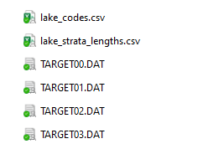
The CSV files (lake_codes.csv and lake_strata_lengths.csv) are lookup tables used by the R program, with lake-specific codes and dimensions that are included in the cleaned output data.
The rest of the files are raw TARGETyy.DAT files. They are sequential files from “TARGET77.DAT” to “TARGET07.DAT”.
Not all TARGETyy.DAT files are shown in this image.

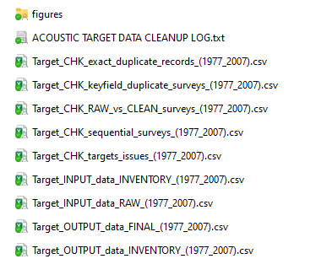
Acoustic Target Data Cleanup.R saves nine different CSV files into the ...\ACOUSTIC_TARGETS\output folder (right), including:
The compiled “uncleaned” data plus inventory:
- Target_INPUT_data_RAW
- Target_INPUT_data_INVENTORY
The “cleaned” output data:
- Target_OUTPUT_data_Final and
- Target_OUTPUT_data_Inventory
And various intermediate “check” files, containing lists of data issues encountered or resolved during program execution:
- Target_CHK_exact_duplicate_records – list of records removed due to duplication of data across all fields or columns
- Target_CHK_keyfield_duplicate_surveys – list of surveys duplicated on key fields (lake, survey_date, survey_type, sounder_type)
- Target_CHK_sequential_surveys – list of surveys that occur within one day of each other for the same lake, representing possible replicate surveys (change in field survey method (e.g., sounder type), or lab analysis method (e.g., software used, technician performed).
- Target_CHK_targets_issues – list of remaining records (if any) with anomalous data issues
- Target_CHK_RAW_vs_CLEAN_surveys – inventory of records organized by whether they exist only in TARGETyy.DAT files (i.e., omitted from cleaned dataset), only in cleaned data (programmatic additions or key-field revisions), or in both.
The contents of these files are further described in “DFO-LEP Acoustic Target Data Issues (1977-2007).pdf”.
Note that the ACOUSTIC TARGET DATA CLEANUP LOG.txt file shown above contains the RStudio console output of a successful run of the R program (not automatically saved to the \output folder).

Output Data Review
While the CSV files can each be opened in MS-Excel or read into R for review and further analysis, a quick look at the R program’s output files can be obtained with the included Excel workbook: “Target_OUTPUT_CHK_data_PIVOT.xlsx”. This workbook contains multiple worksheets, each automatically linked to a corresponding CSV file for ease of data display, filtering, and pivot summary.
Once initial setup is performed (see details in section “To Use the Target Output Checking Data Workbook” in “DFO-LEP Acoustic Target Data Issues (1977-2007).pdf”), the data in “Target_OUTPUT_CHK_data_PIVOT.xlsx” worksheets are automatically updated with the contents of the CSVs upon opening the workbook or refreshing the data.

Additional Metadata Included as a ZIP File
The zip file, DFO-LEP Acoustic Target Data (1977-2007).zip, contains the following folders, following the subdirectory structure of the RStudio project employed to run the Acoustic Target Data Cleanup.R program:


Descriptions of Variables
ats_year: the value of this variable is the egg emergence year of the dominant cohort of juvenile Sockeye salmon (i.e., age-0), but the “ats_year” continues from April 1 in year X to March 31 in year X+1. Before April 1 in year X+1 is when the majority of the age-0 juveniles leave the lake as smolts. Note that juvenile Sockeye in different lakes might emerge (and recruit to the sampling gear) at different times of year, and leave the lake as smolts at different times of year. Therefore, the March 31/April 1 cut-off may not apply to all lakes; the analyst should review published data, technical, and manuscript reports in the Canadian Reports of Fisheries and Aquatic Sciences series (available at DFO libraries) to determine these dates.
lake_code: Lake Enrichment Program code of the lake where data collection occurred
lake: Lake Enrichment Program name of the lake where data collection occurred; lake name retrieved from “lake_strata_lengths.csv”
survey_date: date when the survey was performed, converted from a text format (YYMMDD) in the input files to ISO date format (YYYY-MM-DD)
target_survey_code: - numeric code classification taking the values 1 for JUVENILE or 2 for ADULT survey types, assigned in code. See target_survey_type.
target_survey_type: This survey type indicates the primary/intended type of the survey, ADULT or JUVENILE. This classification is derived from detecting phrasing in either the acoustic_survey_notes or acoustic_survey_comments fields indicating “ADULT COUNT”, “ADULT SURVEY”, “ADULT ESTIMATE”, or similar text. In the absence of specific text indicating an ADULT survey type, the default classification was JUVENILE. See target_survey_code.
survey_year: calendar year that the survey was performed
survey_month: month when the survey was performed
transect: specific transect number associated with a lake survey location
depth_code: numeric integer, one for every unique depth stratum (i.e., if depth_stratum = “2-5” then depth_code = 1, “3-5” is 2, etc.), to classify the lake depth associated with a target count
depth_min_m: minimum depth range (in meters) associated with the depth_code at which targets were ensonified
depth_max_m: maximum depth range (in meters) associated with the depth_code at which targets were ensonified
targets: number of “fish-like” acoustic targets detected (ensonified) in a specific depth range along a particular lake transect
prop_sockeye: proportion of targets that were determined to be Sockeye targets; NA means that the proportion Sockeye was missing in the input data. In addition, if the proportions of Sockeye and Stickleback were both zero in the input data, both proportions were set to NA in code. When the given proportions did not add up to 1.0 +/- 0.01, we have flagged this in the data_issues column. Note: we do not actually know where proportions reported in the TARGET files came from, or how they were derived. We do not place much stock in them, but rely on trawl sampling data for species composition.
prop_stickleback: proportion of targets that were determined to be Stickleback targets; NA means that the proportion Stickleback was missing in the input data. In addition, if the proportions of Sockeye and Stickleback were both zero in the input data, both proportions were set to NA in code.
prop_total: sum of the given proportions of Sockeye and Sticklebacks
transect_length_m: length of transect in units of meters
area_ha: lake area in hectares at a given depth level, which is dependent on the bathymetry of the lake
sounder_code: numeric code of the echo-sounder that was used to collect the data (1 = FURUNO or 2 = SIMRAD; BIOSONICS uncoded)
sounder_type: text field of type of sounder used to collect the data (FURUNO, SIMRAD, BIOSONICS)
sounder_gain: sensitivity of the sounder
sounder_issues: output comment field associated with either sounder code versus sounder type discrepancies, or sounder gain value missing or erroneous
acoustic_survey_notes: metadata provided in the input file regarding the acoustic survey
acoustic_survey_comments: as given in the input data, these are comments that usually include the type of survey that was done or by whom. There are a few comments that are truncated; these are truncated in the input file.
data_issues: comment containing one or more issue(s) that were found in the data during data compilation by R program
key_field_replicate: see section Handling Duplicate and Replicate Surveys, below for explanation
sequential_date_replicate: see section Handling Duplicate and Replicate Surveys, below for explanation
acoustic_source_file: source file name (TARGETyy.DAT, where yy = two-digit value representing individual years from 1977 to 2007) from which the data were imported/compiled.
line_number: line number of a survey or record in the source file.

Handling Duplicate and Replicate Surveys
In general, we define duplicates as identical records on all fields, whereas replicates are records that duplicate some fields but not others. Further details below.
We define duplicate records as records with identical values across all meta-data and data fields. We define exact duplicate surveys as surveys in which all records are duplicates. Duplicate surveys are identified in code and omitted from the final output of cleaned data, as described below.
A survey may be defined as a key-field replicate if another survey exists for the same key fields, i.e., lake, survey date, survey type (e.g., JUVENILE vs ADULT) and sounder type (e.g., FURUNO vs SIMRAD), but differs in other ways: e.g., lab technique (processor, methodology, software settings), or exhibits what are assumed to be updates to the data.
A survey may be defined as a sequential-date replicate if another survey exists for most of the same key fields, i.e., lake, survey type (e.g., JUVENILE vs ADULT) and sounder type (e.g., FURUNO vs SIMRAD), but differs by having a survey date that sequentially follows another survey. This method of saving two survey datasets that are nearly exactly similar may have been a simple ‘desktop protocol’ to differentiate data that differed in other ways: e.g., lab technique (processor, methodology, or software settings), or updates to the data. However, this has not been clearly documented. Rarely would re-surveying a lake on sequential days be executed in the field for the same purpose (i.e., stated survey type) with the same equipment (sounder) -- although Hobiton Lake and Kennedy Lake may be exceptions where experimental re-surveying occurred.
All surveys exhibiting key-field or sequential-date replication have been visually examined (see DFO-LEP Acoustic Target Data Issues (1977-2007).pdf) and, where possible, as based on survey comments/notes, the preferred survey dataset has been identified, and others marked for omission, from the final output data in the R code (see section of R code beginning with # Clean up and flag data issues in data_issues field.)
Exact Duplicates - If two duplicate surveys with identical data were found in the input data, one of them was deleted by the R code (using the distinct() function; see lines 1045 – 1066). A list of exact duplicates is generated at lines 1056-1060, and are exported to CSV in the output CSV file Target_CHK_exact_duplicates_(1977-2007).csv and can be easily reviewed in Target_OUTPUT_CHK_data_PIVOT.xlsx. Commenting out lines 1063-1065 will preserve the duplicate surveys in the output files, if desired.
Key-field Replicates – the key_field_replicate field has values of “NA” or “Replicate survey exists in the original data for this lake, date, sounder, transect and depth.” These replicates may be due to meta-data differences, e.g., different observers (i.e., echogram readers) generating different target values for a given transect and depth, or changes in species composition, or differences in target counts due to changes in echosounder software settings.
All records with apparent duplicates on these fields were examined, and if survey notes/comments revealed definitively which survey dataset was preferred, the other(s) were filtered from the data in the R code, as described below. Data removals via the R code can be revoked by commenting out appropriate portions of lines 436-504 in the R program. A list of remaining key-field replicate surveys can be found in the output CSV file Target_CHK_key_field_replicates_(1977-2007).csv, and can be easily reviewed in Target_OUTPUT_CHK_data_PIVOT.xlsx.
Sequential-Date Replicates – the sequential_date_replicate field has values of “NA” or “Replicate or potential duplicate (with sequential survey dates) exists in the original data.” These replicates may be due to different observers (i.e., echogram readers) generating different target values for a given transect and depth, or changes in species composition, or changes in software settings, but saved with a slightly different date to differentiate from the original survey dataset.
All surveys exhibiting apparent sequential-date replication were examined (see DFO-LEP Acoustic Target Data Issues (1977-2007).pdf), and if survey notes/comments revealed definitively which survey dataset was preferred, the other(s) were filtered from the data in the R code, as described in DFO-LEP Acoustic Target Data Issues (1977-2007).pdf. A list of remaining sequential-date replicates can be found in the output CSV file Target_CHK_sequential_date_replicates_(1977-2007).csv, and can be easily reviewed in Target_OUTPUT_CHK_data_PIVOT.xlsx. Again, data removals via the R code can be revoked by commenting out appropriate portions of lines 436-504 in the R program.

References
- Gjernes, T. W., K. D. Hyatt and D. P. Rankin. 1986. Development of specifications for the use of an uncalibrated echosounder to estimate populations of small limnetic fish. Can. Tech. Rep. Fish. Aquat. Sci. 1509: 35p.
- Hyatt, K. D., D. Rutherford, T. Gjernes, P. Rankin, and T. Cone. 1984. Lake Enrichment Program: Juvenile sockeye unit survey guidelines. Can. Ms Rep. Fish. Aquat. Sci. 1796: 84p.
- Hyatt, K.D., D.P. Rankin, and B. Hanslit. 2000. Acoustic and trawl based estimates of juvenile sockeye salmon (Oncorhynchus nerka) production from 1976 - 1999 brood year adults returning to Smith Inlet and Long Lake, British Columbia. PSARC Working Paper S00-21, DRAFT. 50p. (This draft document is available from the Salmon in Regional Ecosystem Program at Fisheries and Oceans Canada; contact Patrick.Thompson@dfo-mpo.gc.ca.)
- R Core Team. 2023. R: A Language and Environment for Statistical Computing. R Foundation for Statistical Computing, Vienna, Austria. <https://www.R-project.org/>

End of READ_ME Section

Introduction - Acoustic Target Data Issues
The purpose of this document is to outline the data issues encountered while processing the data and to document the various outputs provided by the R program, including (i) information on the raw data inputs and their processing, (ii) the handling/processing of certain data issues such as duplicates and potential replicates, and finally, (iii) the cleaned output data. Examples of duplicates and replicates as defined in the Read_Me section are described in detail, and other data issues associated with echosounder type/use are outlined as well.
While the data team is confident that the effort put into cleaning the Acoustic Targets data has yielded a high quality dataset for immediate use (i.e., Target_OUTPUT_data_FINAL_(1977_2007).csv), all users should familiarize themselves with the information below regarding the data issues encountered and the programmatic interventions and omissions implemented to achieve the final dataset.
As described above in the Data Cleaning section, all output CSV files can each be opened in MS-Excel or read into R for further review and analysis. However, the included Excel workbook: “Target_OUTPUT_CHK_data_PIVOT.xlsx” can also be used to review the R program’s output files. This feature is described in the Post-Processing Data Review section below.

Post-Processing Data Review
To facilitate review of the Microsoft® Excel® workbook is available containing worksheets linked to specific CSV files generated as output by the R program which is linked. See Target_OUTPUT_CHK_data_PIVOT.xlsx [Last updated: 02-Nov-25].
This Excel workbook should be stored in the user’s <LDP ATS Rescue> R project subdirectory. The workbook contains readily accessible copies of the saved CSV datasets generated by the Acoustic Targets Cleanup.R program. Each CSV file in the project Output directory is ‘hot-linked’ to a corresponding Excel workbook worksheet in the Target_OUTPUT_CHK_data_PIVOT.xlsx workbook. The worksheets are grouped (and worksheet tabs colour-coded) by three utility-types, specifically:
- INPUT DATA for Target_INPUT*.csv files – black tabs
- DATA CHECKS for Target_CHK*.csv files – purple, green, blue, and gray tabs
- OUTPUT DATA for Target_OUTPUT*.csv files – yellow tabs.
See the INFO tab in the Target_OUTPUT_CHK_data_PIVOT.xlsx for more information (Table 1 shows some of the columns in the “INFO” tab).
Worksheet names in Target_OUTPUT_CHK_data_PIVOT.xlsx prefixed with “PIVOT” are ‘child’ worksheets containing PIVOT-table-based filtered summary information of a ‘parent’ worksheet. See Table 1 (and/or the “INFO” tab) for a list of parent worksheets (and their corresponding CSV source files), and subsidiary PIVOT table child worksheets.
Most worksheets also have built-in SLICER tables to facilitate visual filtering of the worksheet data (e.g., by lake, survey type and date, sounder type, etc.). The slicer tables can be revised or added to by the user.

To Use the Target Output Checking Data Workbook
After each successful execution of the Acoustic Target Data Cleanup.R program,, open the Target_OUTPUT_CHK_data_PIVOT.xlsx, click the Data menu in the ribbon and select Refresh All to update all Target* parent worksheet ‘hot-links’ and their child PIVOT table worksheets.
Review the PARENT tables to explore the individual CSV output tables (Table 1, below). Use existing (or create new) SLICER filters to drill down to records for specific lakes and surveys, or use associated PIVOT worksheets (where supplied, or create your own) to filter and review summary records.
- The Target_INPUT_data_RAW and Target_INPUT_data_INVENTORY worksheets display pre-processed input data imported by the R program from the raw data in the annual TARGETyy.DAT files (where yy = year).
  - Target_INPUT_data_RAW displays the imported target data records and species proportions (Sockeye and Stickleback only) found in Target_INPUT_data_RAW (1977_2007).csv, by source file, lake code, lake comment, survey date, depth range (m), and transect.
  - Target_INPUT_data_INVENTORY displays an inventory of the imported target data by source file, lake code, lake comment, and survey date, found in Target_INPUT_data_INVENTORY_(1977-2007).csv.
- The Target_CHK_* worksheets document the duplicates analysis.
  - Target_CHK_exact_duplicate tab lists records identified as exact duplicates on all fields and thus omitted from further data-checking and output.
  - The Target_CHK_Key_Field and Target_CHK_Sequential tabs list any remaining potential duplicate/replicate survey data records that were identified by the code – as described below in sections Key-Field Replicate Investigations and Sequential Survey Dates – Potential Duplicates.
Note that a first pass through the data by the program was used to identify initial potential duplicate/replicate records, and where deemed appropriate, was used to include R code to omit likely duplicates or obsolete replicates. These omissions may be revoked in the R code by commenting out the associated filter statements in the section beginning with the comment (approx. line 437 - 504):
# Filter out duplicate survey data identified in LDP Data Issues.PDF
- The Target_CHK_RAW_vs_CLEAN_surveys worksheet provides an inventory of the lake/survey-date combinations in the analysis, classified by source as to whether the survey was:
- found only in the raw data (i.e., omitted entirely from outputs, or modified in the code to alter one or more key fields);
- found only in the final cleaned data (i.e., a function of programmatic revisions to the key-fields for lake and survey); or
- found in both raw import data and cleaned output data inventories.

- The Target_OUTPUT_data_* worksheets display the final “cleaned” acoustic target data, corresponding to analogous Target_OUTPUT_data_*_(1977-2007).csv files outputted by the R program in the Output subdirectory.

  - Target_OUTPUT_data_INVENTORY tab displays an inventory of the imported target data by ATS year, lake code, survey type (juvenile vs. adult), sounder type, and survey date. Each record’s original raw data source file and various acoustic survey comment fields and notes about potential replicates are included.
  - Target_OUTPUT_data_FINAL tab displays the cleaned target data records and species proportions (Sockeye and Stickleback only) by ATS year, lake code, lake comment, survey date, depth code, and transect. The associated transect length (m) and area (m²) at depth (m) are included. Sounder type and other acoustic survey notes derived from the input files are included. Specific issues associated with a given record are listed in the data_issues field. Potential duplicate/replicate data issues are noted in separate fields under column headers key_field_replicate and sequential_date_replicate. The TARGETyy.DAT source file name and the line number in the source file are included in case the user needs to return to the source data for review or verification purposes.

GROUPING | PARENT WORKSHEET | SOURCE CSV FILE | CHILD WORKSHEET
INPUT DATA | Target_INPUT_data_RAW | Target_INPUT_data_RAW_(1977-2007).csv  Compilation of imported data records from TARGET*.DAT files.
 | Target_INPUT_data_INVENTORY | Target_INPUT_data_INVENTORY_(1977-2007).csv  Inventory listing of unique surveys imported from TARGET*.DAT files.
DATA CHECKS | Target_CHK_exact_duplicates | Target_CHK_exact_duplicates_(1977-2007).csv  List of exact duplicate records (i.e., duplicates across all fields); removed from data. | Pivot Exact Dups Removed
 | Target_CHK_Key_Field_Replicates | Target_CHK_Key_Field_Replicates_(1977-2007).csv  List of duplicates on lake, survey date, transect and depth. Matches were visually compared (see LDP Data Issues.docx) and if survey notes or comments were sufficient to distinguish the most representative survey, code was added to ACOUSTIC TARGET DATA CLEANUP.R to omit the other survey data. Remaining key-field replicates are listed in this Excel table. | Pivot Key_Field Replicate List  Pivot Key_Field Replicates
 | Target_CHK_sequential_surveys | Target_CHK_sequential_surveys_(1977-2007).csv  Data associated with replicate surveys that differ by one sequential date, ignoring replicate field survey using different sounders, or for different purposes (e.g., JUVENILE vs ADULT surveys). Beyond that, data managers sometimes replicated surveys (applying a different date) to compare different observer results, or to apply different species proportions (using the same target counts) according to survey notes. Matches were visually compared (see LDP Data Issues.docx) and if survey notes or comments were sufficient to distinguish the most representative survey, code was added to ACOUSTIC TARGET DATA CLEANUP.R to omit the other survey data. Remaining key-field replicates are listed in this Excel table. | Pivot Seq Date Replicates
 | Target_CHK_RAW_vs_CLEAN_ surveys | Target_CHK_RAW_vs_CLEAN_surveys_(1977-2007).csv  Compilation of inventory records, organized by whether the records were found only in the input TARGET*.DAT files (i.e., discarded as duplicates, etc), found only in the final cleaned up data (fixes and additions), or both (input data that have been cleaned for final output).
OUTPUT DATA | Target_OUTPUT_data_FINAL | Target_OUTPUT_data_FINAL_(1977-2007).csv  Compilation of QA/QC'd (cleaned) data records to be saved in Open Data forum.
 | Target_OUTPUT_data_INVENTORY | Target_OUTPUT_data_INVENTORY_(1977-2007).csv  Listing of unique QA/QC'd surveys to be saved in Open Data forum.
Table 1. Linked worksheets in Target_OUTPUT_CHK_data_PIVOT.xlsx and corresponding CSV output files from Acoustic Target Data Cleanup.R. See INFO tab in Target_OUTPUT_CHK_data_PIVOT.xlsx for more information.

Duplicates and Replicates Handling
For definitions of “duplicate” vs. “replicate”, see also the Read_Me section, above. ; however, specifically for handling of duplicates and replicates, see also the Post-Processing Data Review.
Note again that a first pass through the data by the program was used to identify initial potential duplicate/replicate records, and where deemed appropriate, was used to include R code to omit likely duplicates or obsolete replicates. Except for Exact Duplicates (records that are duplicates in all columns), data removals may be revoked in the R code by a user with some coding skills, by commenting out the associated filter statements in the section beginning with the comment (approx. lines 437 - 504).
Exact Duplicates
Duplicate records across all data fields.
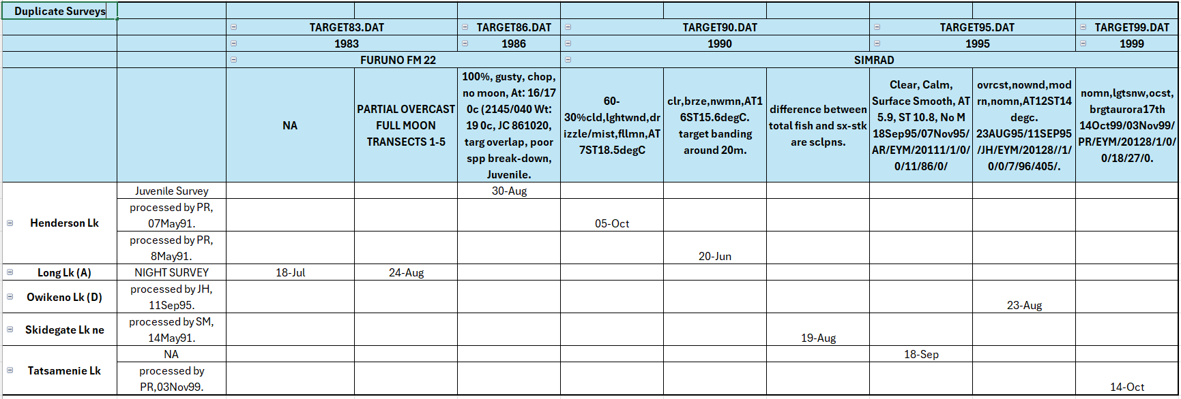
Screenshot listing all exact duplicates found. One instance of each duplicate record set was removed during clean up of the target data, but retained in the source files.

Key-Field Replicate Investigations
Surveys that are not exact duplicates, but have the same key field meta-data (i.e., lake, survey_date, sounder, processor).
These potential duplicates were compared in spreadsheet pivot tables, and handled (or ignored) in the program as described below for each case, below.
See Target_OUTPUT_CHK_data_PIVOT.xlsx.

Key-Field Replicate List
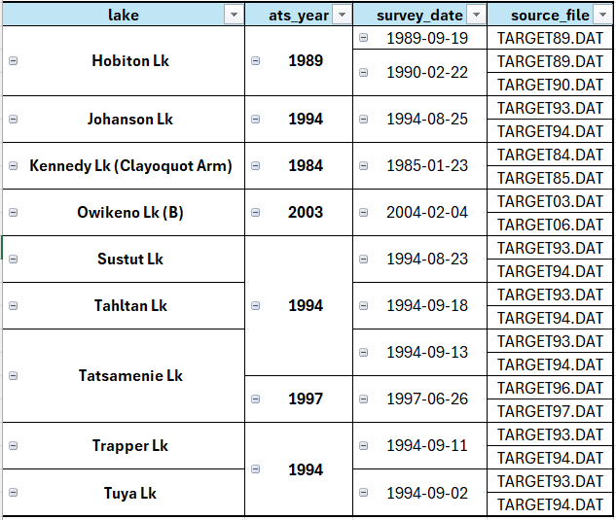

Hobiton Lake - lake_code 6
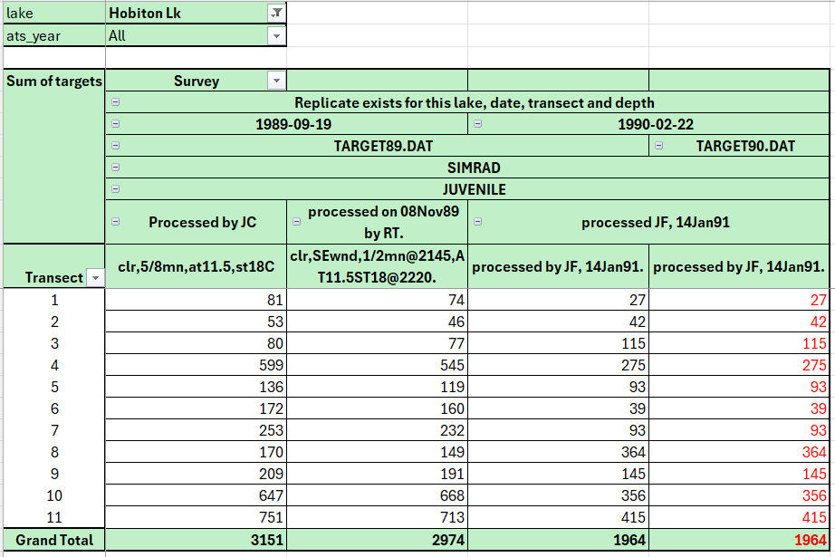
- 89-09-19 - This appears to be a true replicate count of the same echosounder data by different processors (JC and RT), as shown in row 10. No removals advised; both record sets retained in the output data.
- 90-02-22 – version in TARGET90.DAT appears to be a duplicate (placed in wrong TARGET.DAT file) – deleted

Johanson Lake - lake_code 226
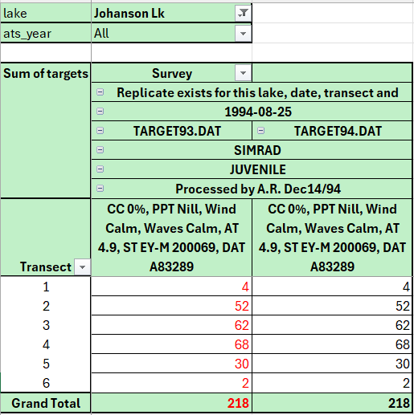
- 94-08-25 – version in TARGET93.DAT appears to be a duplicate (placed in wrong TARGETyy.DAT file) – deleted

Kennedy Lk (Clayoquot Arm) - lake_code 40
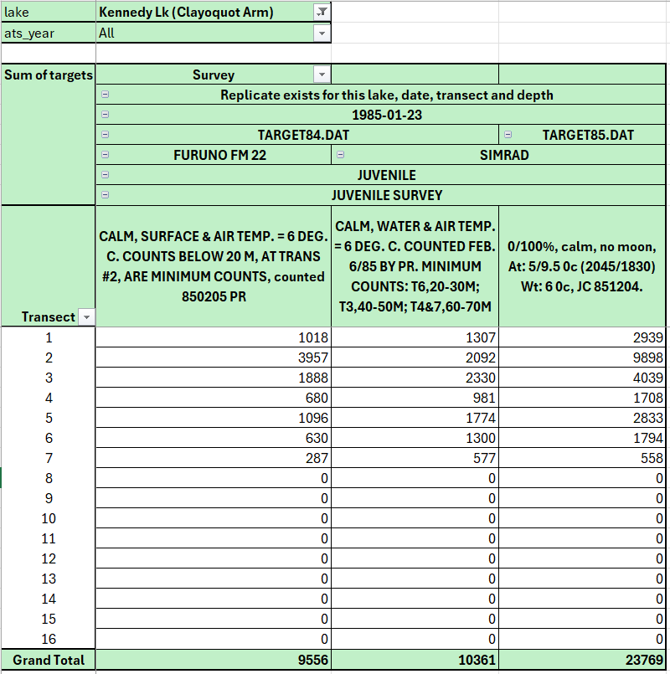
- 85-01-23 - it appears that two field surveys were done for 85/01/23 and stored in TARGET84.DAT, likely valid intentional replicates for hardware comparison: one with Furuno, one with Simrad sounder.
- However, the third ‘replicate’ found in TARGET85.DAT bears little resemblance to either – this may be an incorrectly coded date or lake (might possibly be Kennedy-Main (KMA) instead of Kennedy-Clay (KCA)). It appears to have been processed much later in the year (December) by JC, whereas the TARGET84.DAT datasets were processed by PR (Rankin). No additional info from the meta-data notes were available to inform date assignment. Consult Survey Trip Reports (STRs) or SRE documents (if available) for further clues (these are documents that may be available in the electronic and/or hard copy files of the late Dr. Kim Hyatt; contact Patrick.Thompson@dfo-mpo.gc.ca at the Salmon in Regional Ecosystems Program at DFO). Not removed.

Owikeno Lake (B) - lake_code 229
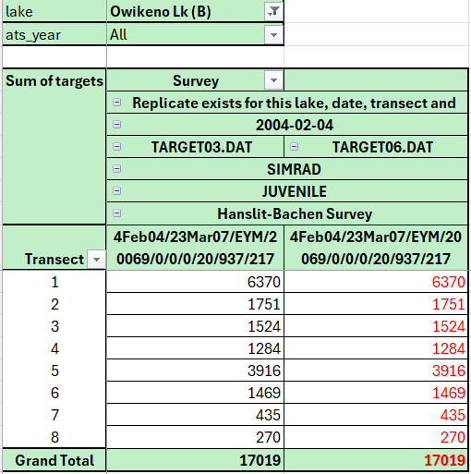
2004-02-04 – version in TARGET06.DAT appears to be a complete duplicate, placed in the wrong TARGETyy.DAT file. Deleted.

Sustut Lk - lake_code 225
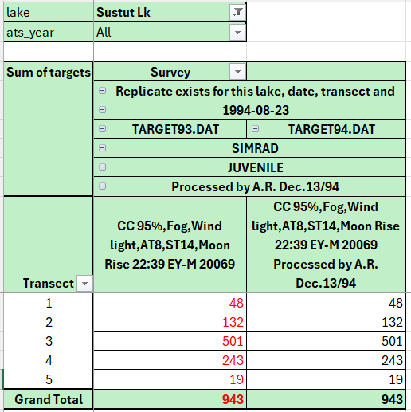
94-08-23 - This appears to be a true duplicate (including targets, spp. proportions), erroneously included in TARGET93.DAT. TARGET94.DAT version has added info in the acoustic_survey_comment line (row 11). TARGET93.DAT version deleted.

Tahltan Lk - lake_code 64
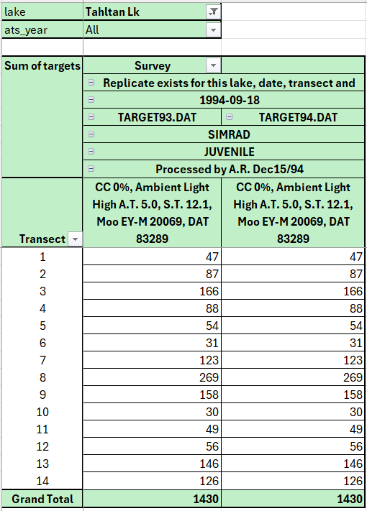
- 94-09-18 - This appears to be a complete duplicate (including targets, spp. proportions), erroneously included in TARGET93.DAT. TARGET93.DAT version deleted.

Tatsamenie Lk - lake_code 66
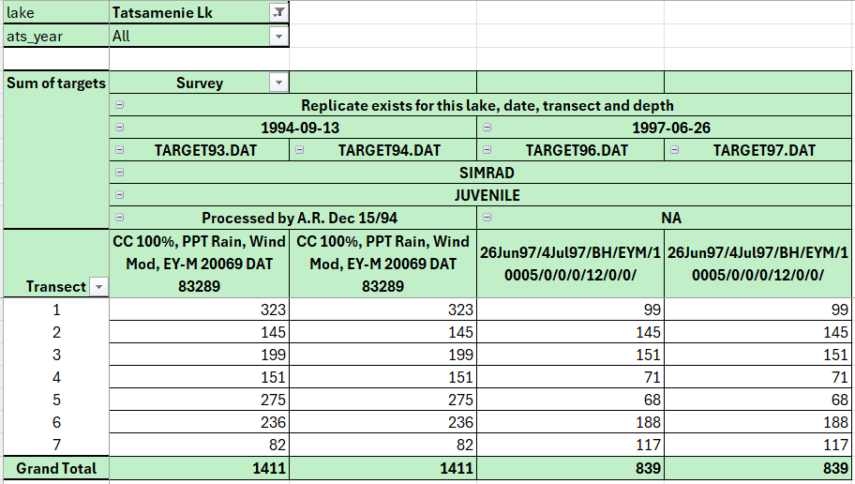
- 94-09-13 - This appears to be a complete duplicate, erroneously included in TARGET93.DAT. TARGET93.DAT version deleted.
- 97-06-26 - This appears to be a complete duplicate, erroneously included in TARGET96.DAT. TARGET96.DAT version deleted.

Trapper Lake - lake_code 67
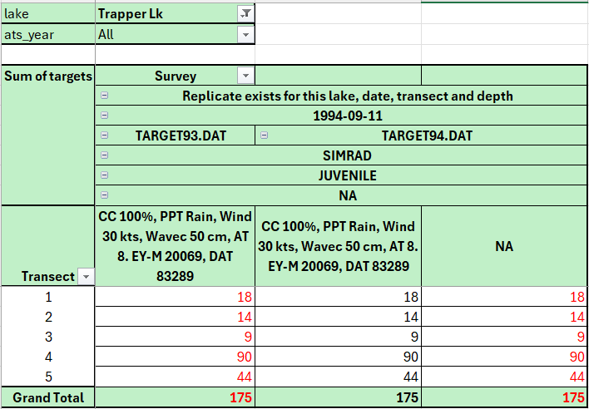
- 94-09-11 – These appear to be complete duplicates, except for the survey notes. TARGET93.DAT version and the TARGET94.DAT version at line number 4541 deleted

Tuya Lake - lake_code 175
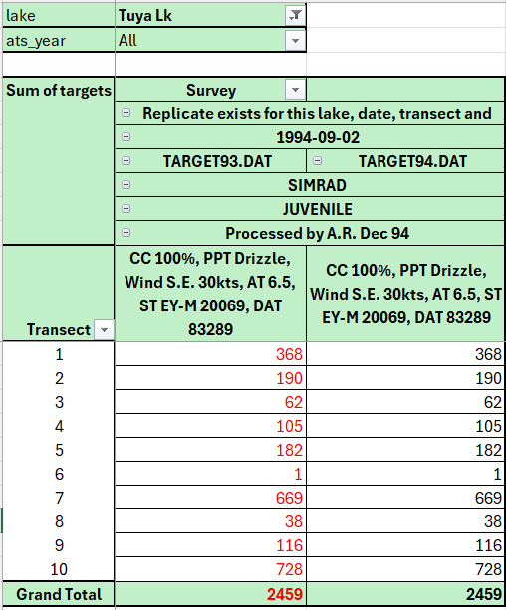
- 94-09-02 – These appear to be complete duplicates. TARGET93.DAT version deleted.

Sequential Survey Dates – Potential Duplicates
See the definitions of duplicates and replicates in the Read_Me section, above.
Includes surveys that have some of the same key field meta-data (lake, sounder, processor), but are on back-to-back survey_dates.
Many of these appear to be simple duplications of the data across the overnight span of the survey effort, since juvenile surveys usually occur in the evening and continue into the early morning hours the next day. It seems that in some cases, this resulted in a copy associated with the date of the survey start time and an additional copy for the next day when the survey was finished.
Other sequential survey_date issues appear to be erroneous inclusions of a single survey record set in two different TARGETyy.DAT files, possibly due to some confusion regarding the ATS-year to which to attribute a survey. For example, a survey from March 1991 should normally be included in TARGET90.DAT as it falls into the April’90 to March’91 ATS-year, but may show up erroneously in TARGET91.DAT. It is not clear why the duplicate was sometimes saved with a different date of one day, however.
In other cases, the sequential date occurrences appear to be bona fide replicate field surveys, testing different sounder types, or targeting juveniles versus adults (which probably involves revised sounder gain settings for larger targets). Usually ADULT surveys are noted in the TARGET*.DAT files in the acoustic_survey_comment field or survey_notes field, and, if the word ADULT SURVEY is found in these fields, the program applies a survey_type classification to the record, set to ADULT (default JUVENILE). Another clue is that Adult target counts are significantly fewer in number than Juvenile target counts around the same date.
Finally, there may be replicate echogram reading efforts ‘back in the lab’, by different processors (echogram readers), with different software (e.g., EYM versus EY500?), or with different goals (e.g., minimum versus full counts), yielding different target counts on or around the same date. It seems like it was common practice to save these replicates with a slightly different date.
Certain ‘replicate’ surveys involve revisions to the species proportions, based on updated trawl data, or adjustments for size bias in trawl observations. This might suggest that the uncorrected dataset should be omitted/deleted. The rationale for the extra dataset is not always made clear in the meta-data, however.
All sequential potential duplicates were exported to CSV and compared in spreadsheet pivot tables, and handled (or ignored) in the program as described below each case. Only obvious duplicate record sets are removed from the output dataset, via filtering mechanisms in the R code. Suggested removals are (usually) marked in red below in the screengrab and the explanatory text; where indicated, these have in fact been deleted from the final cleaned file, Target_OUTPUT_data_FINAL_(1977_2007).csv, that was provided to GC Open Data.
See the Target_CHK_sequential_surveys tab, or its source CSV file: Target_CHK_sequential_surveys_(1977_2007).csv.

Brannen Lake
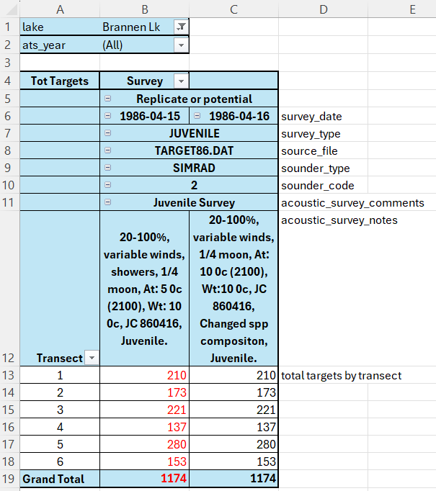
This appears to be a duplicate survey, but acoustic_survey_notes indicates that the 860416 version has revised species composition (prop_sockeye and prop_stickleback), which was verified in TARGET86.DAT. 86-04-15 version was deleted.

Cheewhat Lake
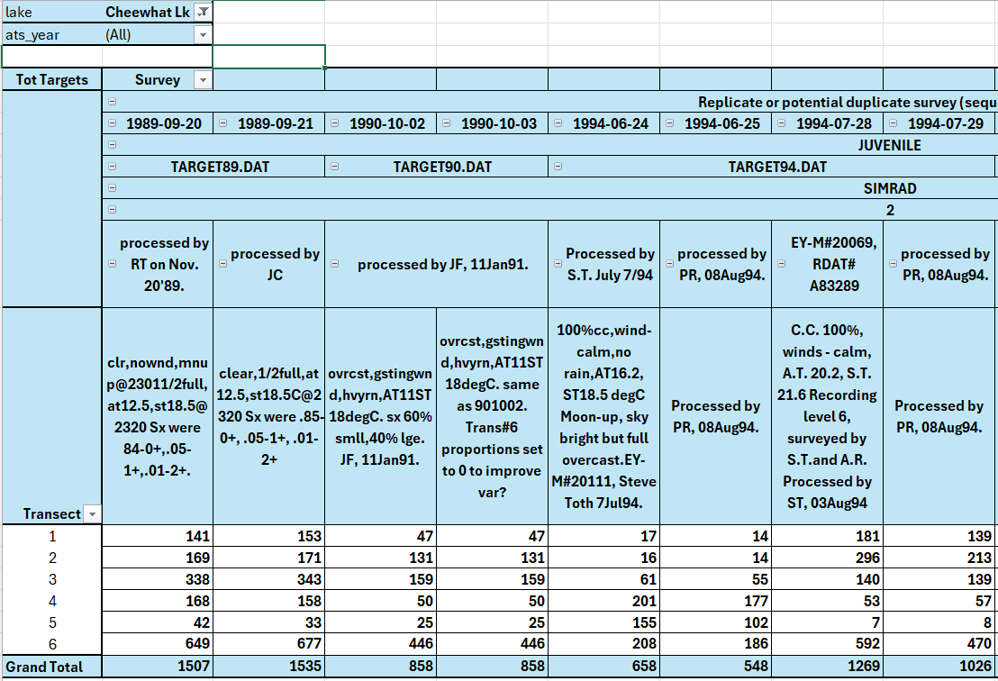
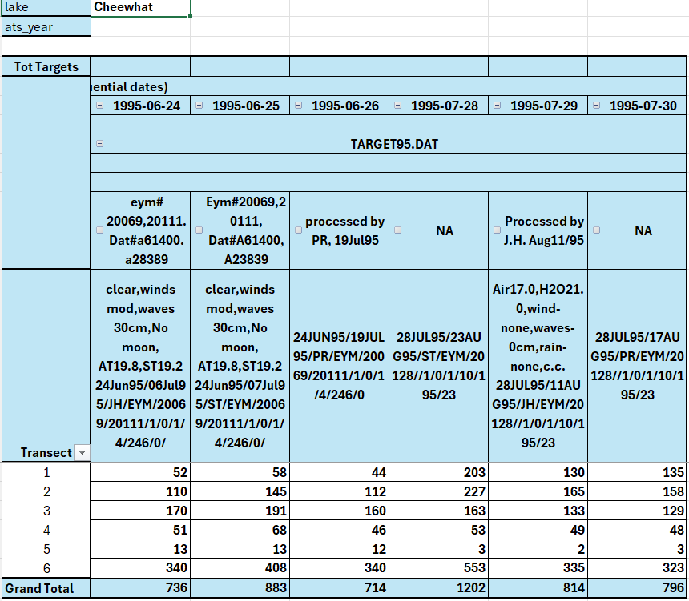
These all appear to be bona fide replicates of some sort, via different lab processors, as based on the metadata provided in the originals.
None removed.

Devon Lake
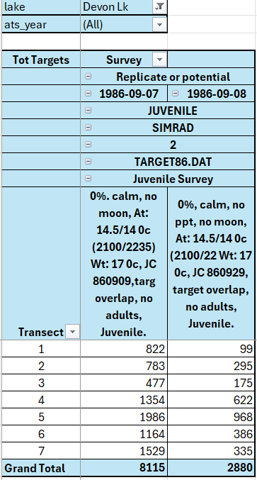
Both survey analyses suggest some methodological change to the counting to deal with target overlap. No removals.

Eden Lake
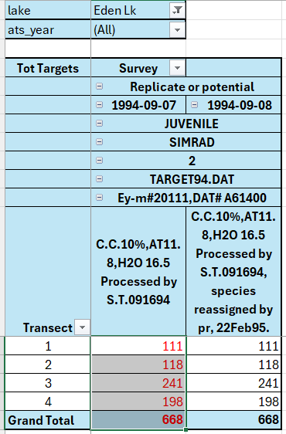
- 94-09-07 and -08 datasets indicate change in species proportions by PR. 94-09-07 deleted.

Great Central Lake
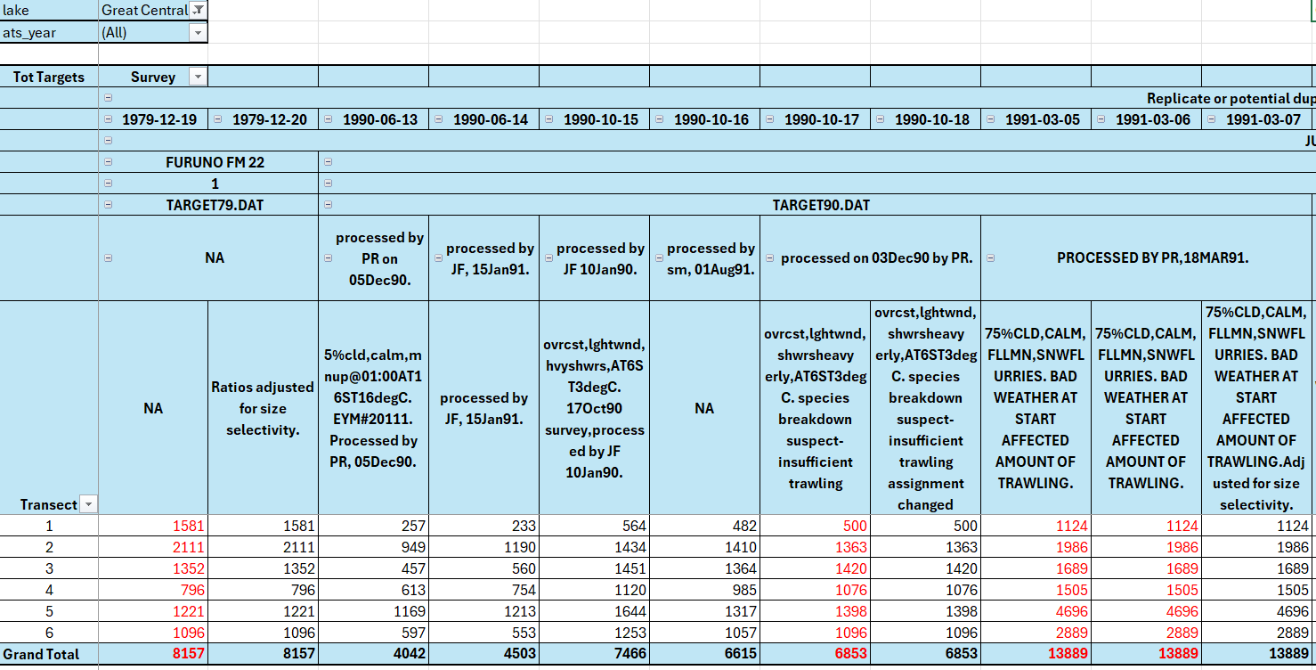
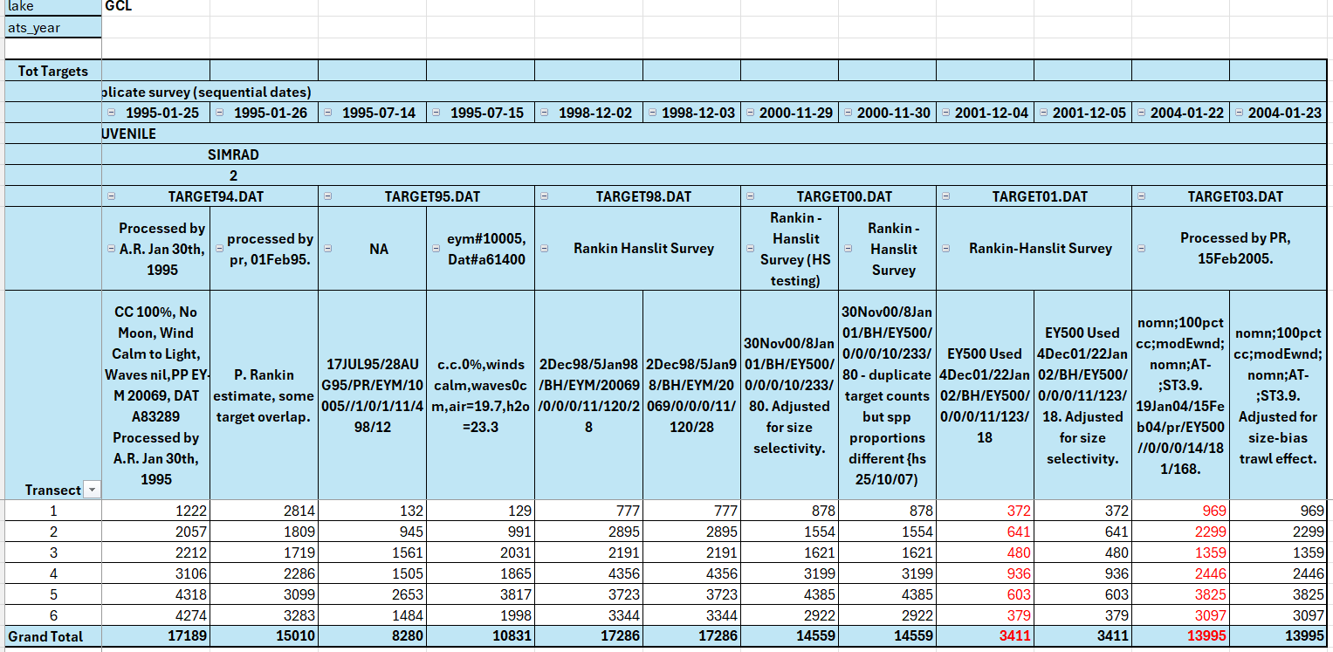
- 79-12-19 – deleted because 79-12-20 species proportions adjusted for size selectivity
- 90-06-13 & 90-06-14, 90-10-15 & 90-10-16: bona fide replicates; no deletions necessary
- 90-10-17 and -18 – species proportions adjusted as compared to 90-10-16; 90-10-17 deleted.
- 91-03-05 and 91-03-06 – deleted, as duplicates of 91-03-07 which was adjusted for size selectivity
- All 1995 data shown here – bona fide replicates, no deletions necessary
- 98-12-02 and 98-12-03 – duplicate target numbers, but species proportions differ, with no comment on which analysis is best. 98-12-02 deleted, assuming the fix was in 98-12-03.
- 2000-11-29 and 2000-11-30 - duplicate targets, but species proportions differ, with 2000-11-29 adjusted for size selectivity. 2000-11-30 deleted.
- 2001-12-04 – deleted; 2001-12-05 had spp. proportions adjusted for size selectivity.
- 2004-01-22 – deleted; 2004-01-23 had spp. proportions adjusted for size selectivity.

Henderson Lake
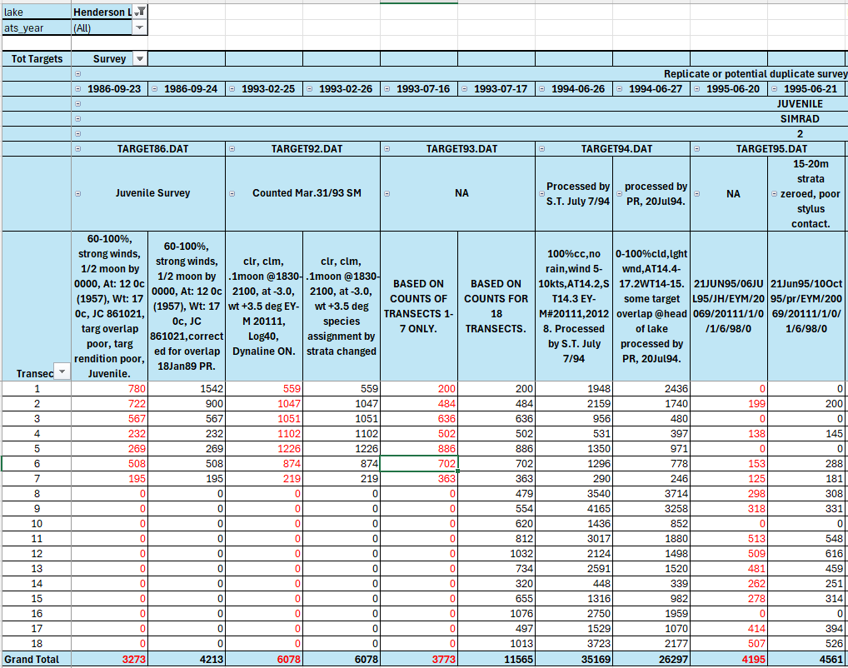
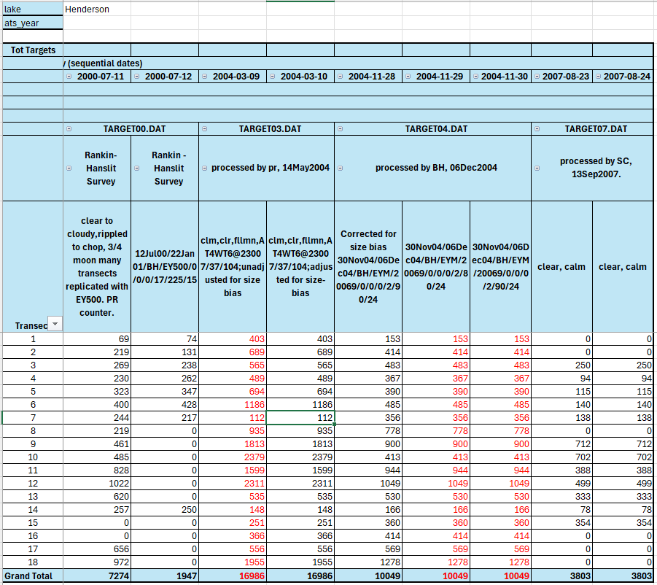
- 86-09-23 – deleted, as 86-09-24 has corrections
- 93-02-25 – deleted, as 93-02-26 has corrections to species proportions
- 93-07-16 – deleted, as 93-07-17 was based on all transects
- 94-06-26 and 94-06-27 are assumed to be bona fide replicates due to differences in methodology
- 95-06-20 – deleted, as 95-06-21 appears to be the revised version (i.e., more metadata associated with it)
- 2000-07-11 and 2000-07-12: here the nature of the differences are unclear, therefore all data retained
- 2004-03-09 – deleted, as 2004-03-10 has adjustments for size bias
- 2004-11-29 and 2004-11-30 – both deleted, as 2004-11-28 has adjustments for size bias
- 2007-08-23 / 2007-08-24 – differs in species proportions for some transects/depths, but unclear which version is the ‘adjusted’ version. 2007-08-23 deleted.

Heydon Lake
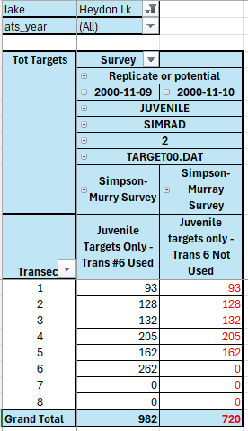
- 2000-11-10 deleted, as incomplete, according to comments

Hobiton Lake
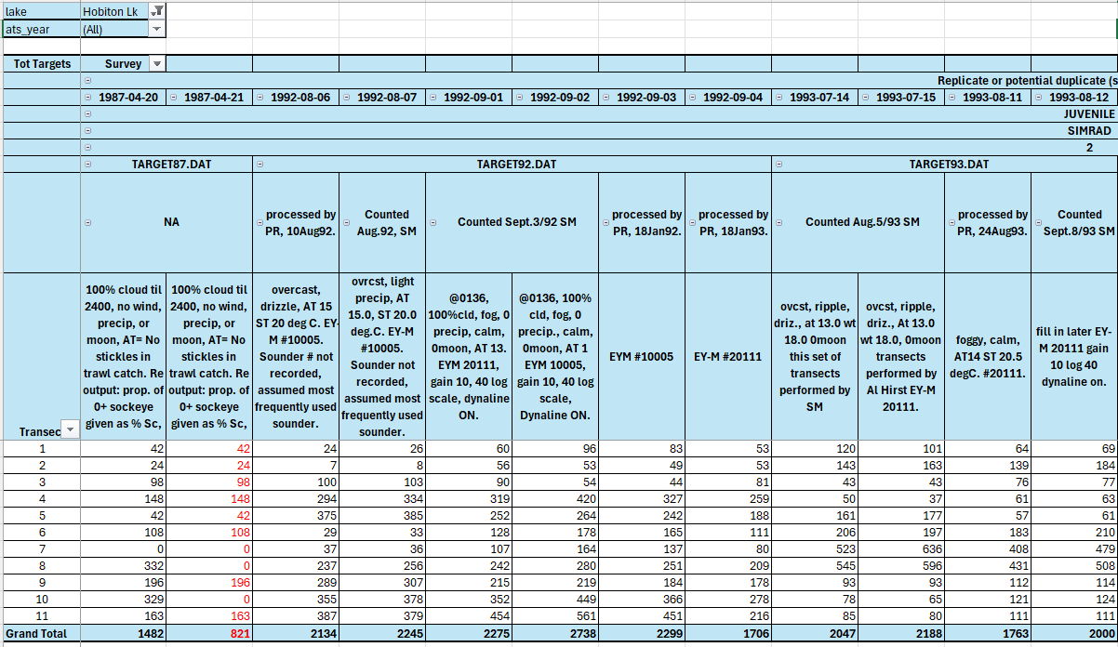
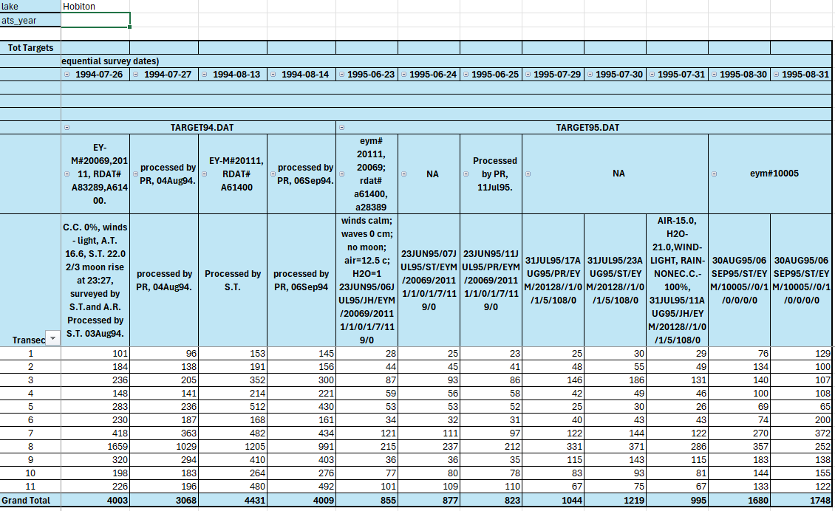
- 87-04-20 & 87-04-21 – latter assumed incomplete, deleted
- 1992, 1993, 1994, 1995 surveys – different methods or processors – no removals because it’s unclear which of the replicates are correct.

Ian Lake
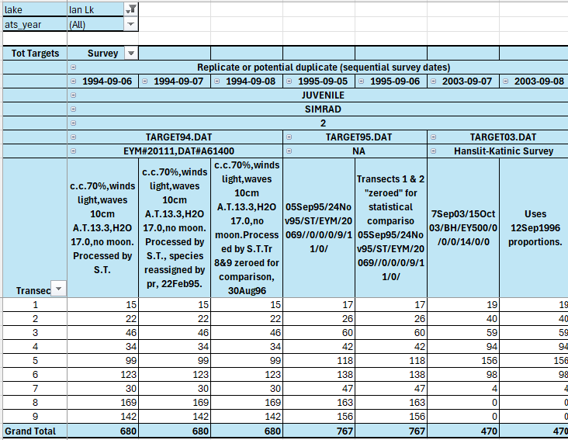
- 1994, 1995 surveys – different species compositions, therefore all records retained
- 2003 surveys – different species proportions, no preference given, 2003-09-07 deleted assuming 2003-09-08 has a fix

Kennedy Lake (Clayoquot Arm)
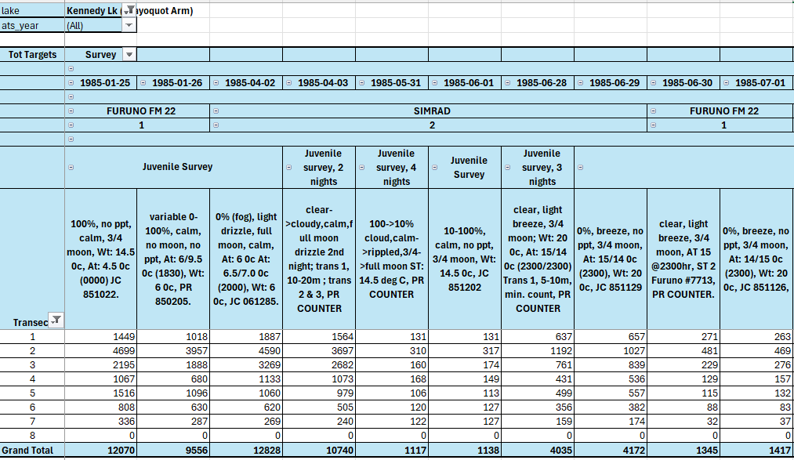
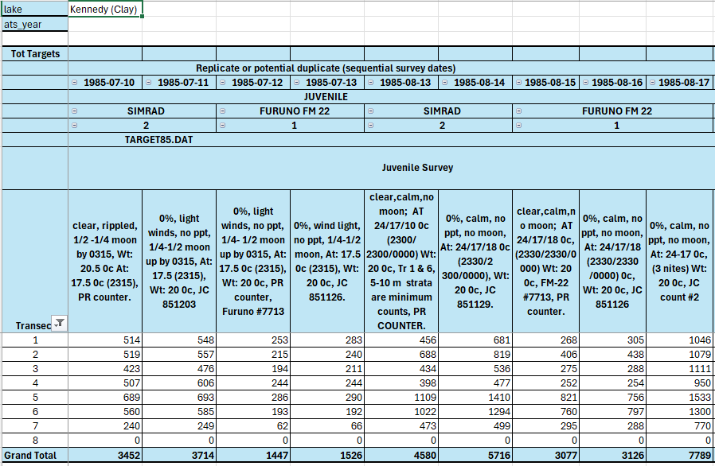
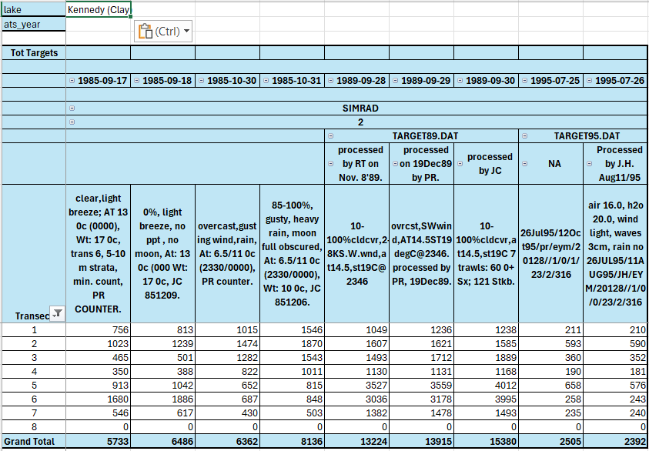
- All surveys displayed appear to be bona fide replicate field surveys or different lab processor/methods. No changes advised.

Kennedy Lake (Main Arm)
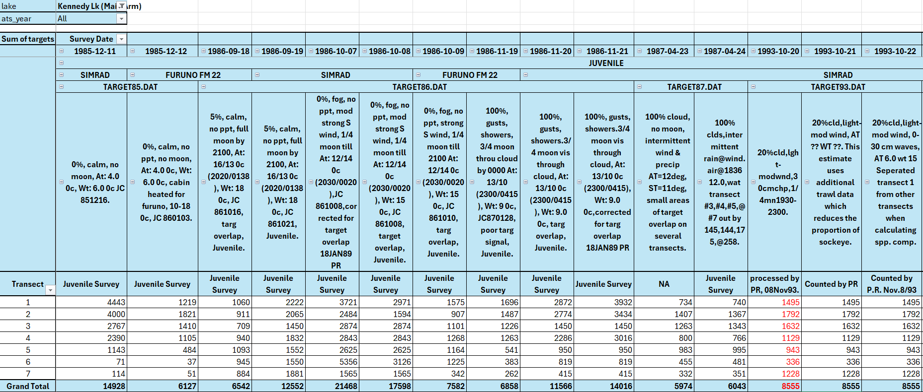
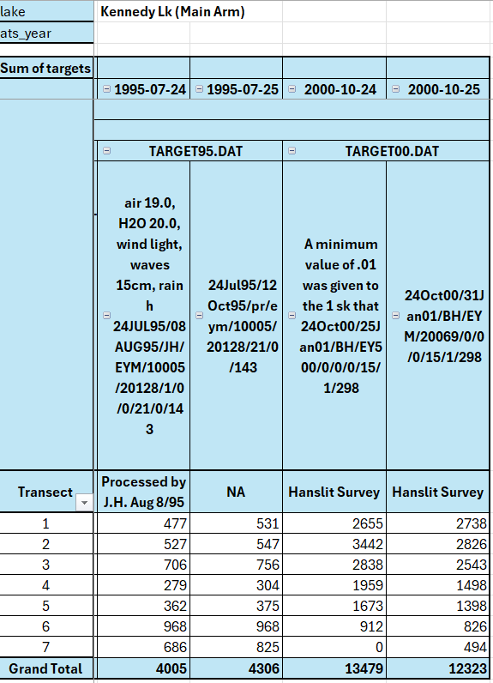
- 93-10-20 & 93-10-21 – deleted, superseded by 93-10-22
- In the lower table, assumed bona fide replicates.

Long Lake (A)
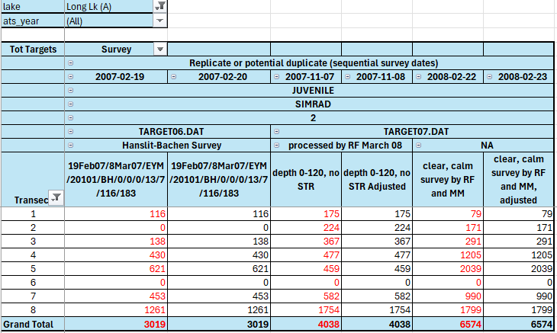
- 2007-02-19 – appears identical to 2007-02-20, i.e., no changes in targets or proportions; 2007-02-19 deleted
- 2007-11-07 – deleted, given 2007-11-08 is identical but with adjusted proportions
- 2008-02-22 – deleted, given 2008-02-23 is identical but with adjusted proportions

Long Lake (B)
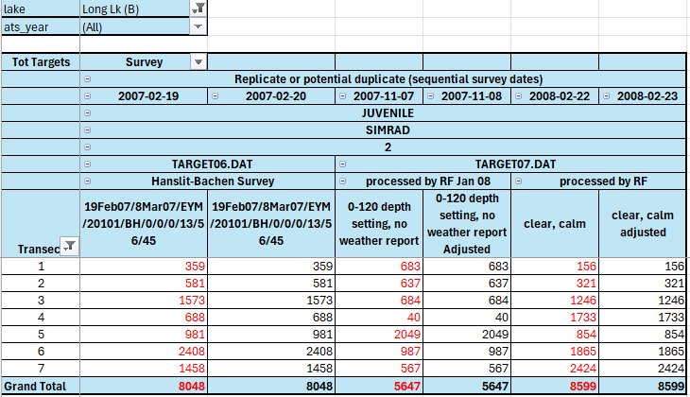
- 2007-02-19 – appears identical to 2007-09-20, i.e., no changes in targets or proportions; 2007-02-19 deleted
- 2007-11-07 – deleted, given 2007-11-08 is identical but with adjusted proportions
- 2008-02-22 – deleted, given 2008-02-23 is identical but with adjusted proportions

Mercer Lake
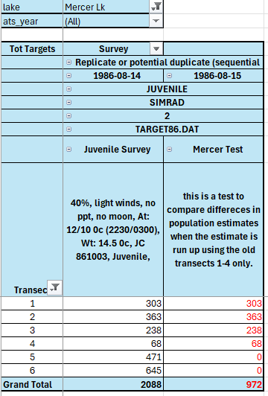
- 86-08-14 vs. 86-08-15 – a comparison in pop estimates with two transects excluded, may be useful for calibrating surveys based only on transects 1-4, although that kind of analysis seems doable with any and all surveys that feature all six transects. Note that 860814 is more complete, so 86-08-15 was the logical deletion.

Meziadin Lake
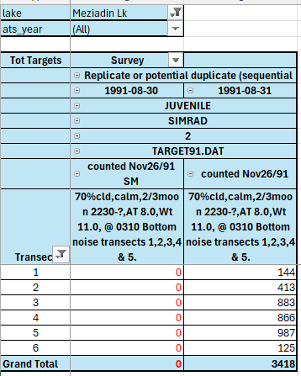
- 91-08-30 – deleted, as it contains only zeros for targets (and spp. composition).

Muchalat Lake
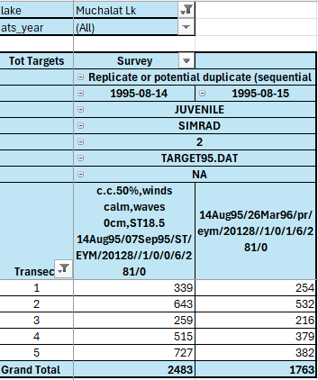
- 95-08-14 and 95-08-15 – different processors; no changes required

Muriel Lake
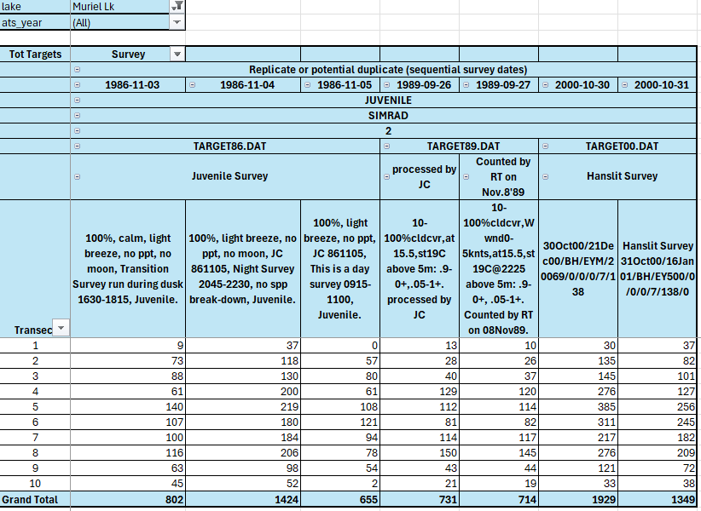
- 86-11-03 and -04 and -05 – comparative surveys at different times of day; no changes required
- 89-09-26 and -27 – different processors; no changes required
- 2000-10-30/31 – appear to be different readings on different dates; no changes advised

Nimpkish Lake
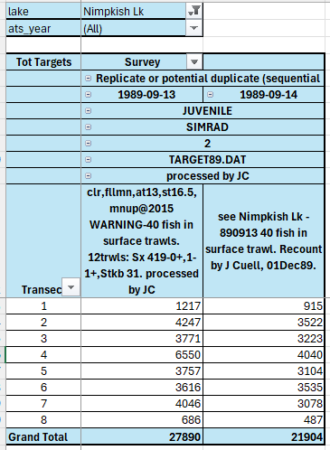
- 89-09-13 and -14 – different processors; no changes required

Phillips Lake
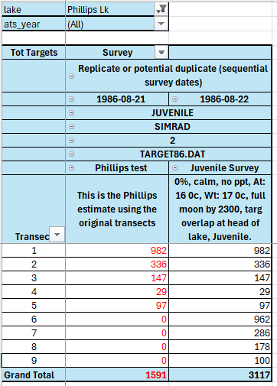
- 86-08-21 vs 86-08-22 – a comparison in pop estimates with four transects excluded, may be useful for calibrating surveys based only on transects 1-5, though that kind of analysis seems doable with any and all surveys that feature all nine transects. Note that 86-08-22 is more complete, so 86-08-21 was the logical deletion.

Osoyoos Lake (N)
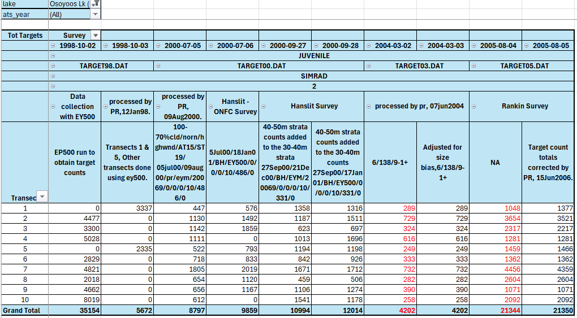
- 98-10-02, and -03 – complementary transect data from different methods (EP500 vs EY500); presumably 98-10-03 was focused on transects 1 and 5 to fill in the blanks in 98-10-02, but that is not clearly stipulated. Both datasets retained.
- 2000-07-05/06 – different processors
- 2000-07-27/28 – different count analyses though same processor
- 2004-03-02/03 – 04-03-02 deleted as 04-03-03 species proportions were adjusted for size bias
- 2005-08-04/05 – 05-08-04 deleted as 05-08-05 target counts were corrected

Owikeno Lake (A)
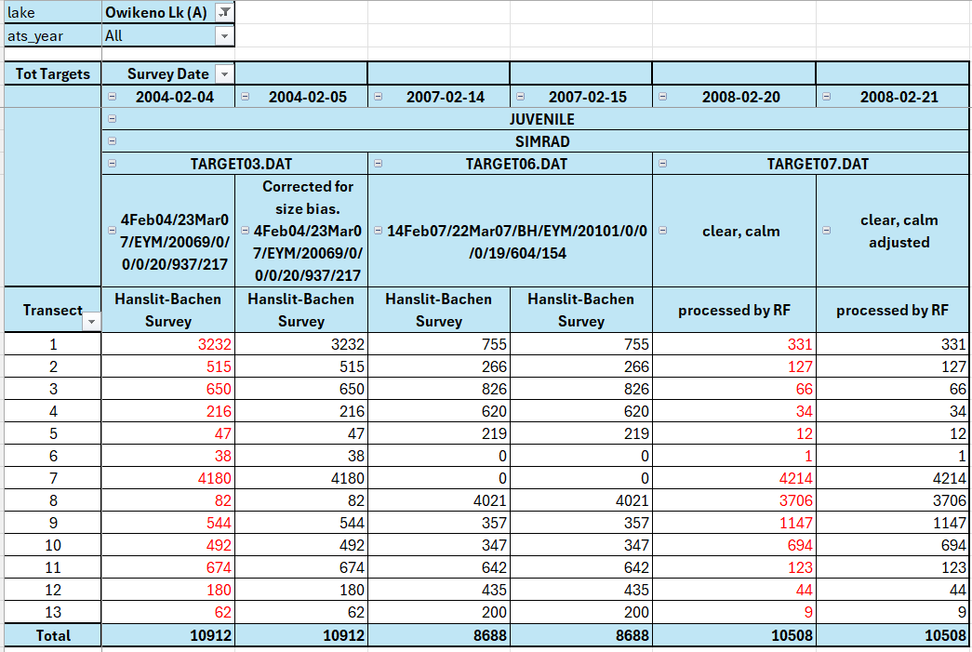
- 2004-02-04 – deleted, as 2004-02-05 adjusted for size bias
- 2007-02-14/15 – data contain different species proportions without indication of rationale (size bias?) or which survey was adjusted (likely 070215). 2007-02-14 deleted.
- 2008-02-20 – deleted, as 2008-02-21 adjusted for size bias

Owikeno Lake (B)
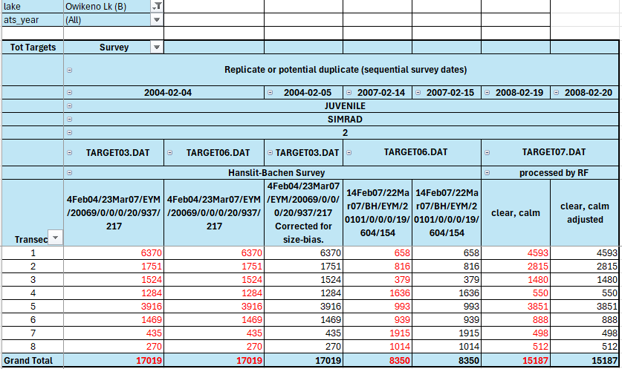
- 2004-02-04 – and copy from TARGET06.DAT: deleted, as 2004-02-05 adjusted for size bias
- 2007-02-14 and -15 – data contain different species proportions without indication of rationale (adjusted for size bias?) or which survey was adjusted (likely 07-02-15). 2007-02-14 deleted.
- 2008-02-19 – deleted, as 2008-02-20 adjusted for size bias

Sakinaw Lake
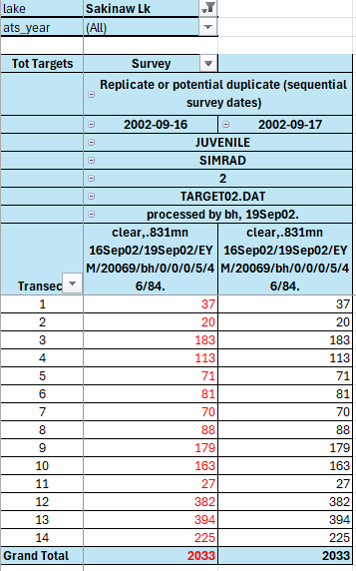
- 2002-09-16/17 – survey data have different species proportions, without notes on which survey is correct, assume the second one is correct. 2002-09-16 deleted.

Skaha Lake
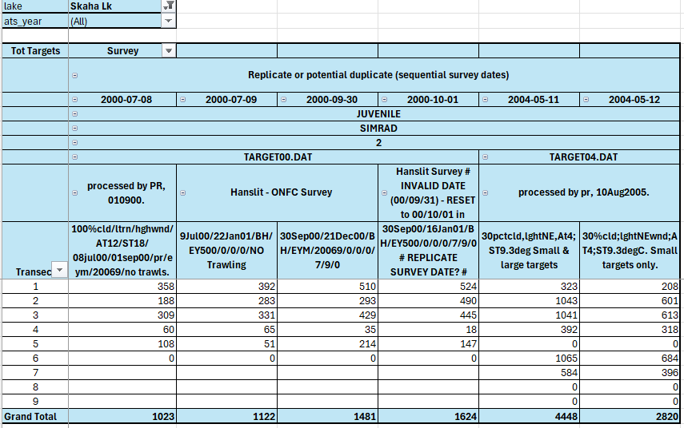
- 2000-07-08/09 – different software (EYM vs EY500?); no changes advised
- 2000-09-30/10-31 – different software (EYM vs EY500?); no changes advised
- 2004-05-11/12 – different target size inclusion; no changes advised

Sproat Lake
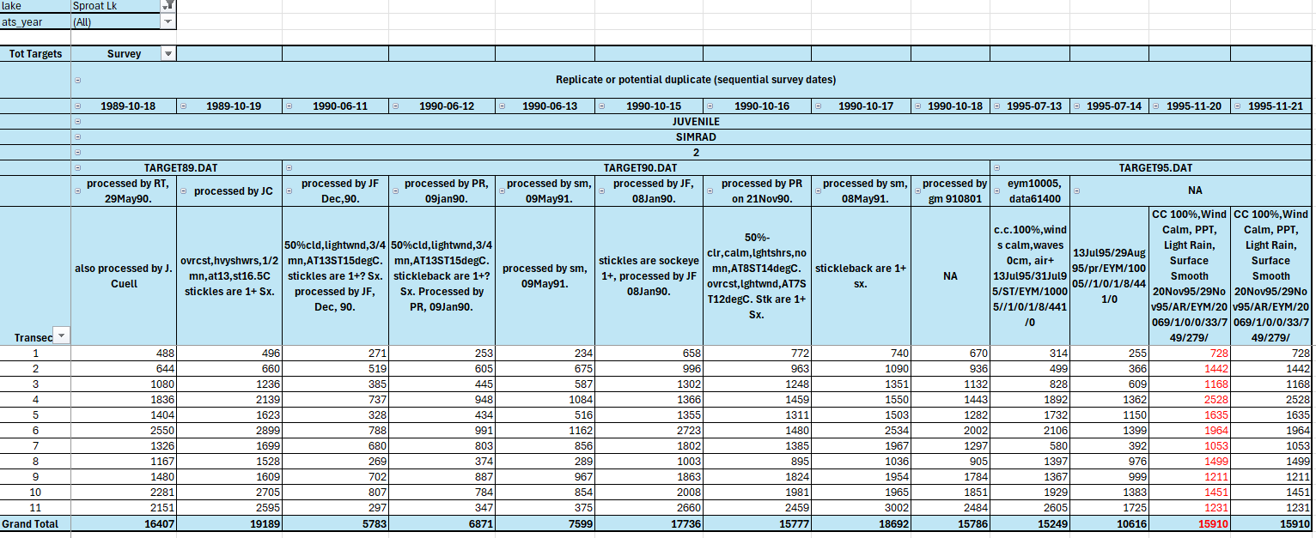
- 1989 & 1990 and 95-07-13 and -14 surveys: different processors; no removals
- 95-11-20 and -21 – different species proportions, but no final preference specified; deleted 95-11-20

Skidegate Lake NE
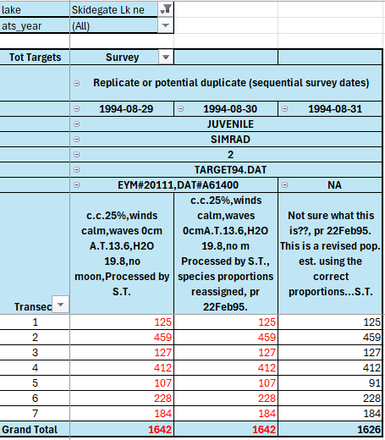
- 94-08-31 appears to be the final but target counts in transect 5 differ. 94-08-29 and 94-08-31 deleted. Kept 94-08-30 since PR re-assigned proportions (i.e., ignore red font colour in table for 94-08-30).

Trapper Lake
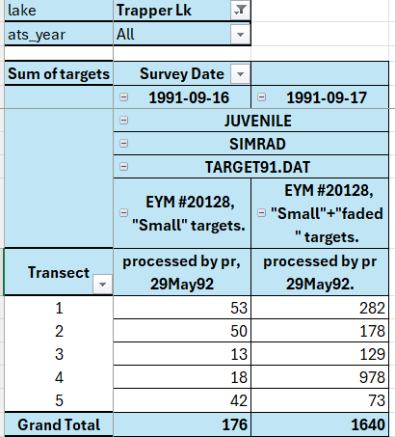
- 91-09-16 and -17 – different estimates based on target size; unclear which is valid, but the second one seems to be a correction to the first. 91-09-16 deleted.

Tuya Lake
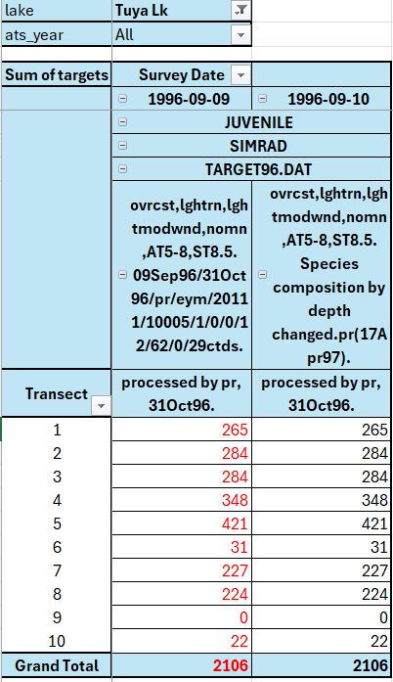
96-09-09 and -10 – 96-09-09 deleted based on updates to species composition in 96-09-10.

Vernon Lake
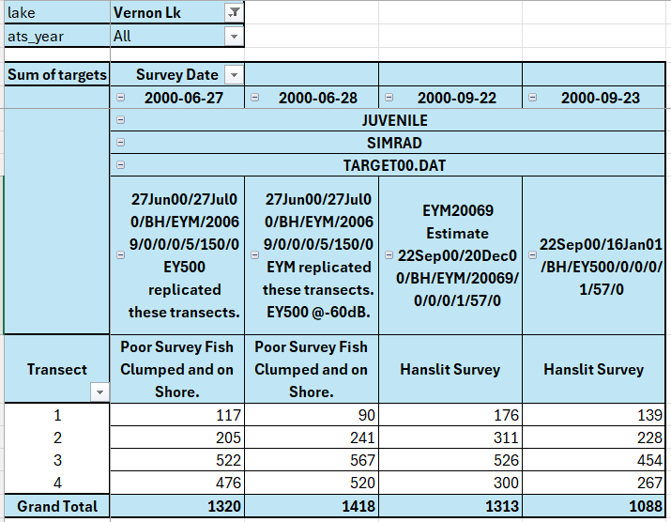
- 2000-06-27/28 – different software (?) : EY500 vs EYM? No changes advised
- 2000-09-22/23 – different software (?) : EY500 vs EYM? No changes advised

Woss Lake
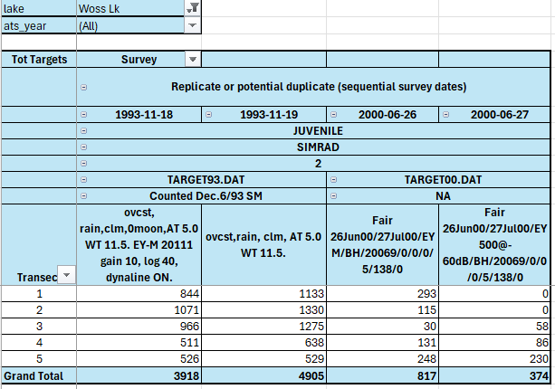
- 93-11-18 and -19 – unclear what the different survey datasets represent; consult STRs (Summary Trip Reports) Neither deleted.
- 2000-06-26/27 – EYM vs EY500 unit differences – no changes advised.

Yakoun Lake
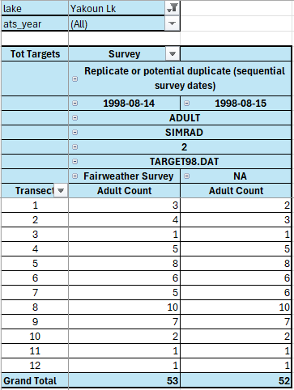
- 98-08-14 and -15 – unclear as to what the difference in targets is due; consult STRs? 98-08-14 deleted.

Other Data Issues
The Acoustic Target Data Cleanup.R program checks for a number of other data incongruencies and potential errors, and flags these with a text comment in the data_issues field for the affected record(s). Users should review the data_issues field, as well as the sounder_issues, acoustic_survey_comments and acoustic_survey_notes fields for issues, prior to using these data in the Target_OUTPUT_data_FINAL worksheet of the Target_OUTPUT_CHK_data.xlsx workbook.
In addition, the ACOUSTIC TARGET DATA CLEANUP LOG.txt file, saved from the RStudio console after program execution, lists the following types of data issues in various fields.

Sounder Issues

Sounder Code Check
The target data from 1977-2009 were mostly generated using two types of echo-location sounders: FURUNO and SIMRAD, with sounder codes 1 = FURUNO; 2 = SIMRAD. Sounder name and sounder code are recorded in the TARGETyy.DAT import data on the same line.
Of the 1,324 surveys reviewed, 292 were associated with FURUNO models, 1,026 were done with SIMRAD units, and 3 were associated with BIOSONICS devices, for which no code has been provided. In addition, 3 surveys were identified as FURUNO-based, but with sounder_code = 2 (SIMRAD). It is not clear from the data which component of the sounder information line is incorrect, the code or the model name for these three surveys, and no changes have been made to these records.
sounder_code sounder_type n_occurrences issue
1 FURUNO FM 22 275
1 FURUNO FM22 8
1 FURUNO 5
1 BIOSONICS G12 3 no sounder code assigned
1 FURUNO FE 501 1
1 FURUNO FG 200 1
1 FURUNO FG 21 1
1 FURUNO FM 22 1
2 SIMRAD 1026
2 FURUNO FM 22 1 erroneous type or code?
2 FURUNO FE 501 1 erroneous type or code?
2 FURUNO FM22 1 erroneous type or code?
TOTAL 1324

The apparently erroneous sounder assignments can be filtered for records where sounder_issue contains “Sounder Code/Type discrepancy”. The lake surveys and their source files include the following:
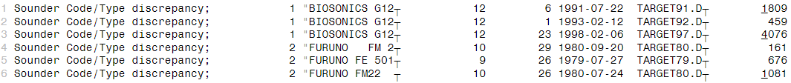

Sounder Gain Check
The sounder gain value is missing (NA) or erroneous (>50) for the following surveys:
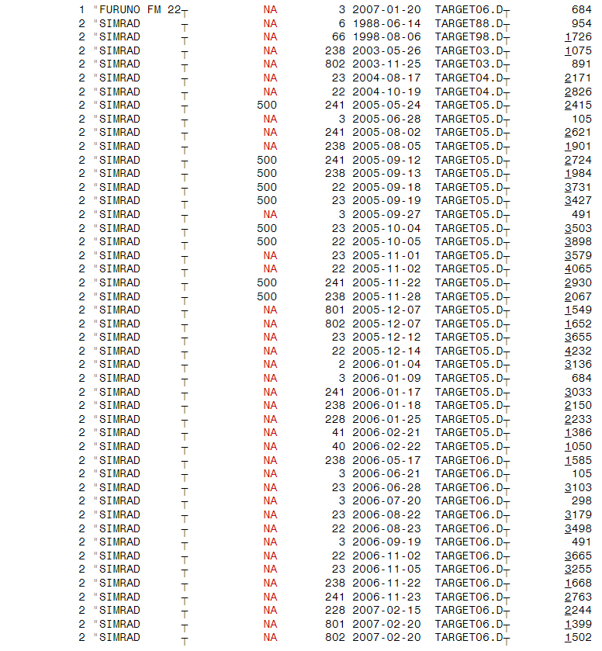

List of Data Issues Types and their Frequency
The following table is a partial list of the types of data_issues and their frequency in the final output data. Multiple data issues may be identified for a given record. Individual data issues are separated by a semi-colon in the text in the data_issues field. Due to truncation of the text in this table, not all of the data_issues are fully listed below. See the Target_OUTPUT_data_FINAL worksheet of the Target_OUTPUT_CHK_data.xlsx workbook for the complete data_issues information.
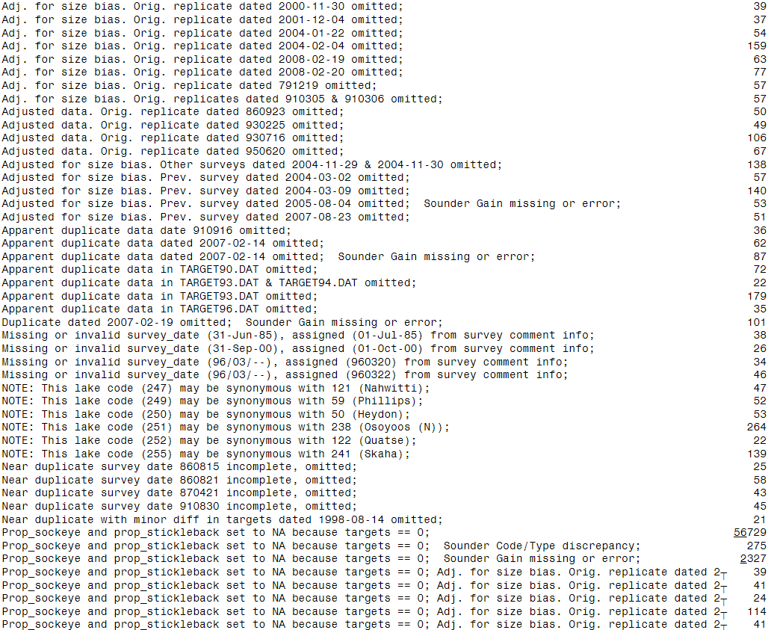
Cont’d.

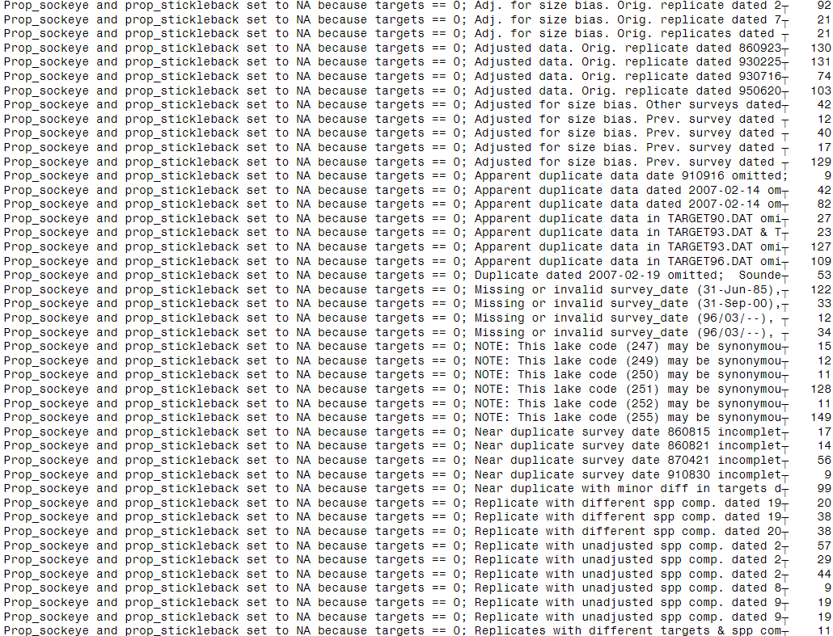
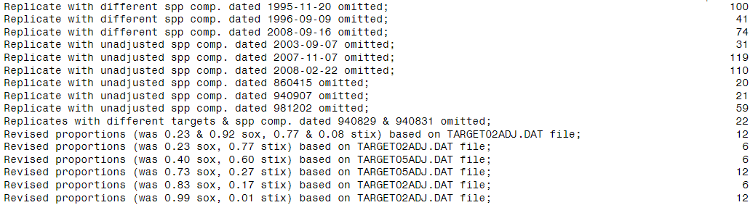
Cont’d.
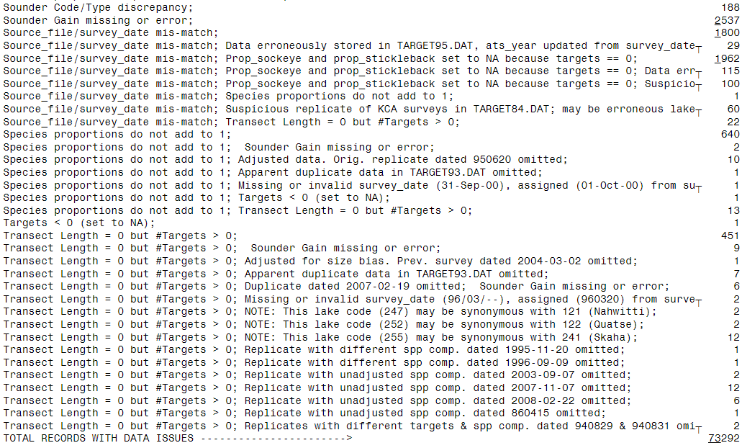

Microsoft® Excel® for Microsoft 365 MSO (Version 2502 Build 16.0.18526.20546) for 64-bit computers.
Successful execution of program displays execution time in the console window in RStudio, such as: Acoustic Target Data Cleanup program complete. Execution time: 5.88 minutes [01-Nov-2025]
See Acoustic Target Data Cleanup Log.txt in the output sub-directory for a typical log file for a successful execution of the R program.
Problems with linking worksheets to the CSVs? This is a likely event upon initial setup, and will also occur any time the location of the Output directory changes, but should not occur upon subsequent Acoustic Target Data Cleanup.R program runs. To refresh links, click the Data menu in the ribbon, and select Queries and Connections menu item. This will bring up the Queries window - right-click on any Query in the window, and choose Edit to bring up the Power Query Edit window. Select Data Source Settings in the menu to list all data sources. Select each data source and click the Change Source Settings button, then browse to location of corresponding CSV.
Note that *.DAT files can also be viewed using a text editor.

